Arthur Ivson Xavier de Moraes Batista - #301063251

Pablo Saldarriaga Gonzalez - #301092976

Cong Wang - #301098547

HackDivision Games

January 27th, 2021

Version 1.0

A Run to get Home

COMP 397Web Game Programming Team Project

Table of Contents

Version History 2

I. Game Overview 3

II. Game Play Mechanics 3

III. Camera 3

IV. Controls 3

V. Saving and Loading 3

VI. Interface Sketch 4

VIII. Game World 7

IX. Levels 7

X. Game Progression 7

XI. Characters 7

XII. Non-player Characters 7

XIII. Hazards 7

XIV. Weapons 7

XV. Collectables 7

XVI. Abilities 8

XVII. Script 8

XVIII. Scoring 8

XIX. Puzzles/Mini-games 8

XX. Bonuses 8

XXI. Cheat Codes 8

XXII. Sound Index 8

XXIII. Story Index 8

XXIV. Art / Multimedia Index 9

XXV. Design Notes 9

XXVI. Future Features 9

**Version History**

|  |  |  |
| --- | --- | --- |
| No. | Version | Description |
| 1 | 1.0 | Basic playable version including running player |
|  |  |  |

**I.** **Game Overview**

***Hacky****, the protagonist of our story is trying to get home after awakening in a strange city unknown to him. The game is based on an urban environment hostile to the player.*

***A Run to get Home*** *is a runner-type game where the main character,* ***our hero,*** *runs around the city obtaining coins and different types of gems. Each coin and gem has a different value in the game and these values are going to be relevant at the end of the level to designate how many stars the player gets. To pass the level, the player needs to get at least 2 stars out of 5.*

*When running,* ***Hacky*** *needs to avoid obstacles such as garbage bins, vehicles, constructions, pets, pedestrians and other things related to the environment. If* ***Hacky*** *collides with any obstacle, he loses some coins and his life bar decreases by one. When the life bar gets to 0, the game is over and the level needs to be restarted.*

**II.** **Game Play Mechanics**

*When selecting* ‘*start level’,* the selected level already starts *with* ***Hacky*** *running, so the player doesn’t need to keep pressing a specific button. The player can go to the right, left, jump, double jump or slide, to get coins and gems, and to avoid collision with obstacles.*

**III.** **Camera**

*Third person view.*

**IV.** **Controls**

* *Arrow Up / W / space - Jump*
* *Arrow Left / A - Move to the left*
* *Arrow Right / D - Move to the right*
* *Arrow Down / S - Slide*

**V.** **Saving and Loading**

*The game saves the position of the player and the number of the coins collected and loads from there.*

**VI.** **Interface Sketch**

* *Left-top icon: enter settings menu.*
* *Right-top icon: the number of coins or other items collected.*
* *right-bottom icon: sound switch.*

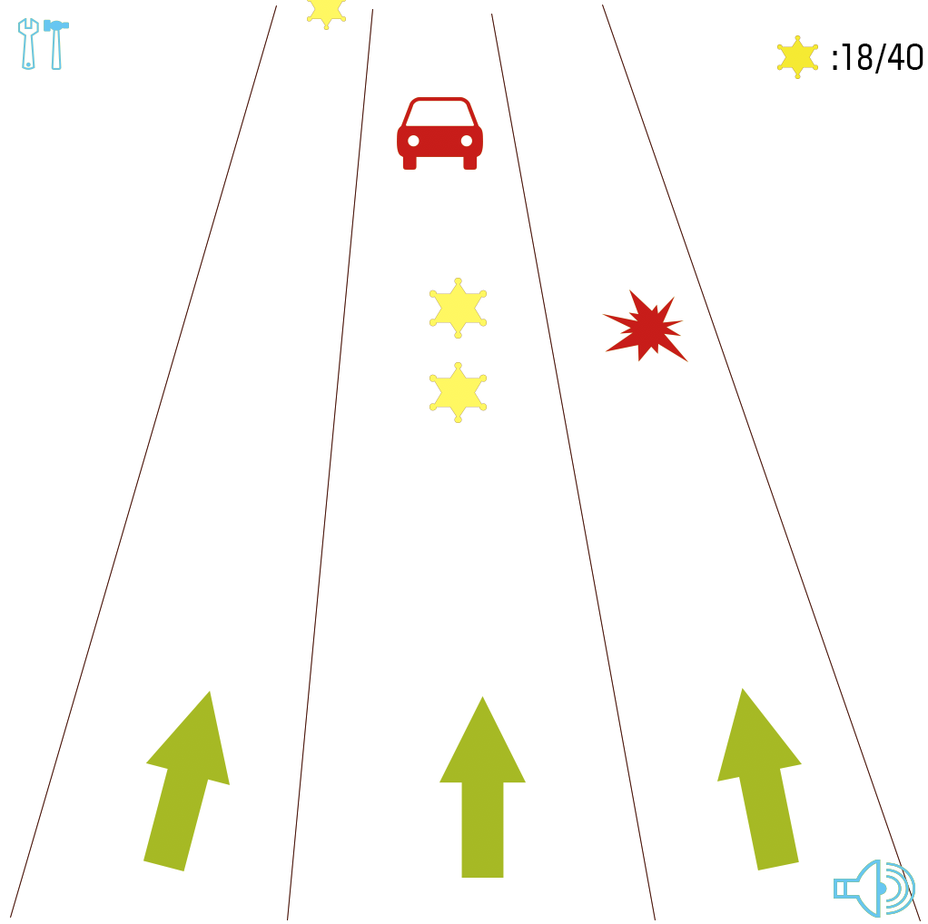

**VII.** **Menu and Screen Descriptions**

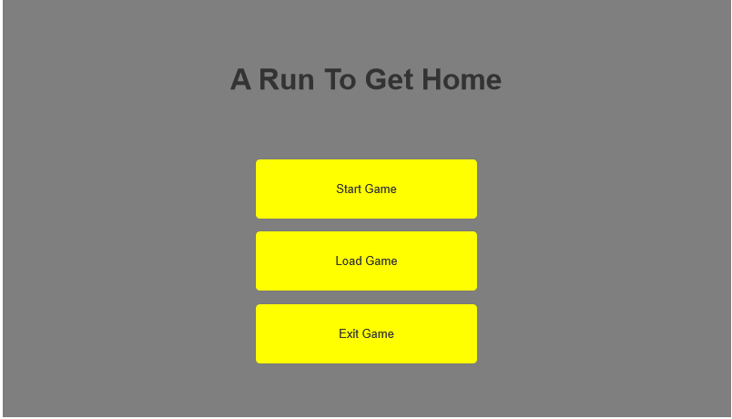



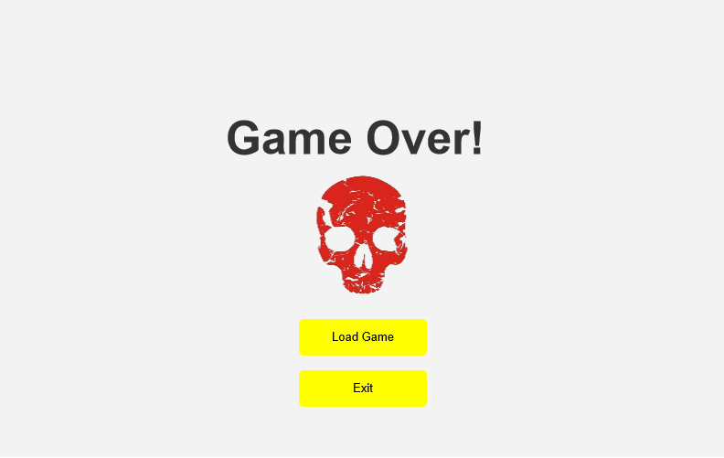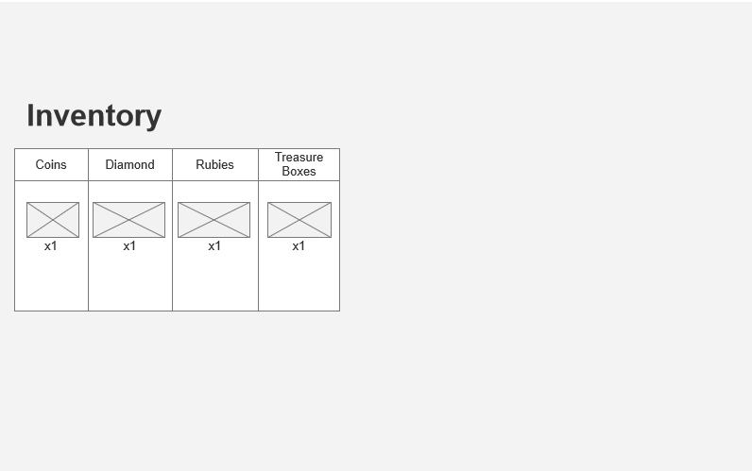

**VIII.** **Game World**

*The game is based in a 21st century and apparently regular city. Hacky needs to get home soon as soon as possible, but he encounters traffic jams, pedestrians, pets, garbage bins and constructions blocking his way and making his task more and more lengthy.*

**IX. Levels**

*On all levels,* ***the player*** *has the same goal, to reach his home, but he starts at a different point in the city. A School, a Park, the Beach and a Shopping Mall.*

**X.** **Game Progression**

*When the player reaches the end of a level he will receive starts depending on the amount of points that he/she obtained. These stars will vary according to the different gems and coins that the player obtains when running. In addition to this, the player needs to have one or more HP points in his life bar, otherwise, he won’t be able to make it.*

**XI.** **Characters**

* *Hacky, our hero and a guy who seems to always be in a rush.*

**XII.** **Non-player Characters**

*(NOT APPLICABLE)*

**XIII.** **Hazards**

*The enemies will be the barriers encountered in the city. for example:*

* *Vehicles(static, dynamic)*
* *Barries*
* *Wall*

**XIV.** **Weapons**

*(NOT APPLICABLE)*

**XV.** **Collectables**

* *Coin: common item. Coins will have* ***1 points*** *value in the game.*
* Magnetic cube: collect coins more easily as if the player is like a magnet*.*
* Accelerating cube: player will run faster after collecting accelerating cube.
* Double-jump cube: player will get the ability of jumping twice.
* *Double score cube: player will collect one coin as two points.*

**XVI.** **Abilities**

***Hacky*** *will be able to jump to dodge obstacles. Furthermore, there are multiple magic cubes which allow Hacky to have different capabilities.*

**XVII.** **Script**

*(NOT APPLICABLE at this moment)*

**XVIII.** **Scoring**

*All the items (section XV) will appear in a moment in the game worth a value and these values will influence how many stars (maximum five) the player will have at the end.*

* *1 star: Less than 200* ***points***
* *2 stars: Less than 400* ***points***
* *3 stars: Less than 600* ***points***
* *4 stars: Less than 800* ***points***
* *5 stars: 800 or more* ***points***

**XIX.** **Puzzles/Mini-games**

*(NOT APPLICABLE)*

**XX.** **Bonuses**

***(NOT APPLICABLE)***

**XXI.** **Cheat Codes**

*(NOT APPLICABLE)*

**XXII.** **Sound Index**

* *Collecting coins sound:* [*https://opengameart.org/content/10-8bit-coin-sounds*](https://opengameart.org/content/10-8bit-coin-sounds)
* *Bg music:* [*https://opengameart.org/content/jump-and-run-tropical-mix*](https://opengameart.org/content/jump-and-run-tropical-mix)

**XXIII.** **Story Index**

*The story of the game is stating the danger of the city. Both challenges and opportunities exist. Which weighs more in players’ minds, challenges or opportunities.*

**XXIV.** **Art / Multimedia Index**

[*https://pan.baidu.com/s/1U4z4GfqNSKwMBn8SmbnyKQ*](https://pan.baidu.com/s/1U4z4GfqNSKwMBn8SmbnyKQ) *4wic*

**XXV.** **Design Notes**

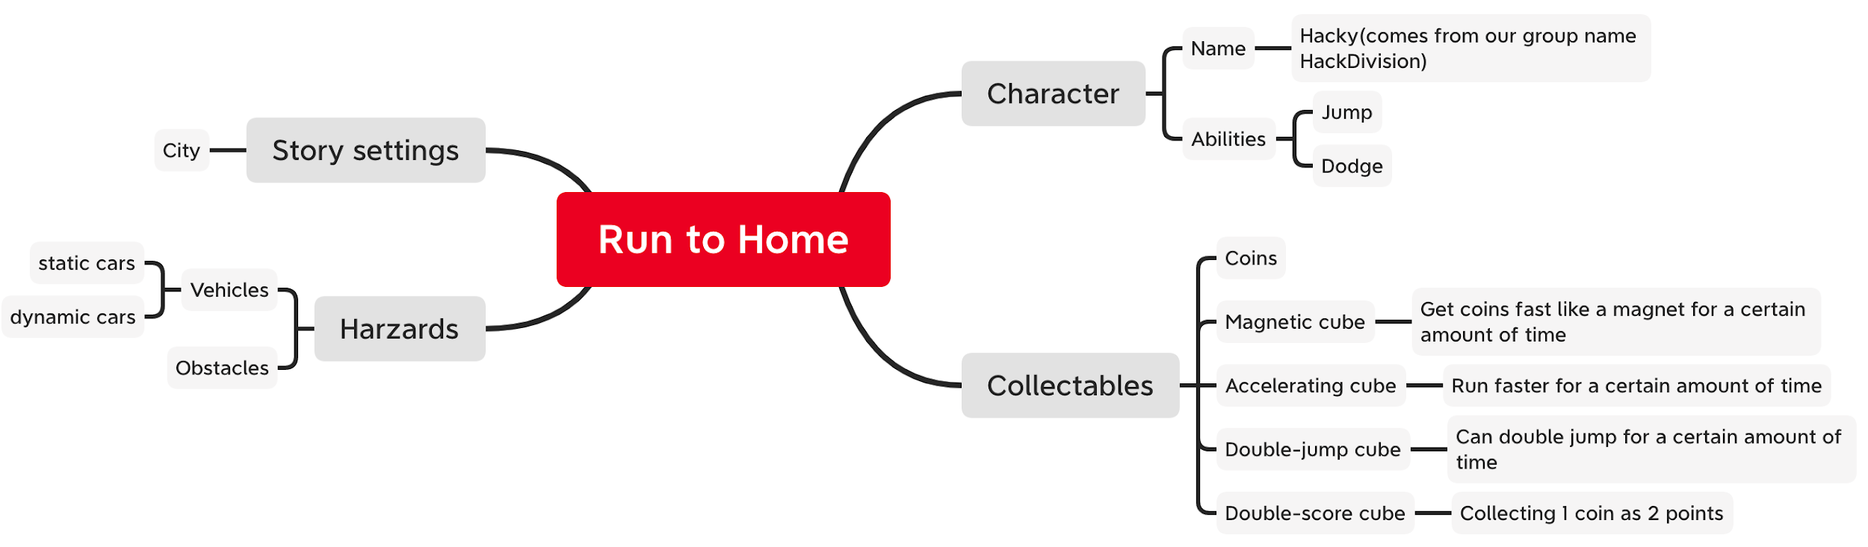

**XXVI.** **Future Features**

* ***Hacky*** *will be able to destroy the obstacles with some power or special item.*
* ***Hacky*** *will be able to get an airplane + bonus items to avoid obstacles.*
* *The map will have more branches.*